**Practical – 6**

**Aim: -** Identify the IP address of a workstation and the class of the address and configure the IP Address on a workstation.

All the computers of the world in the Internet network communicate with each other with underground or underwater cables or wirelessly. If I want to download a file from the internet or load a web page or literally do anything related to the internet, my computer must have an address so that other computers can find and locate mine in order to deliver that particular file or webpage that I am requesting. In technical terms, that address is called IP Address or Internet Protocol Address.

An IP address is a unique address that is used to identify computers or nodes on the internet. This address is just a string of numbers written in a certain format. It is generally expressed in the set of numbers for example 192.155.12.1. Here each number in the set is from 0 to 255 range. Or we can say that a full IP address ranges from 0.0.0.0 to 255.255.255.255. And these IP addresses are assign by IANA (known as Internet Corporation For Internet Assigned Numbers Authority).

But what is Internet protocol? This is just a set of rules that makes the internetwork. You are able to read this article because your computer or phone has a unique address where the page that you requested has been delivered successfully.

**Working of an IP Addresses: -**

The working of IP addresses is similar to other languages. It can also use some set of rules to send information. Using these protocols we can easily send, receive data or files to the connected devices. There are several steps behind the scenes. Let us look at them: -

1. Your device directly requests your Internet Service Provider which then grants your device access to the web.
2. And an IP Address is assigned to your device from the given range available.
3. Your internet activity goes through your service provider, and that they route it back to you, using your IP address.
4. Your IP address can change. For example, turning your router on or off can change your IP Address
5. When you are out from your home location your home IP address doesn’t accompany you. It changes as you change the network of your device.

**Types of IP Address: -**

1. **IPv4 :-** Internet Protocol version 4. It consists of 4 numbers separated by the dots. Each number can be from 0-255 in decimal numbers. But computers do not understand decimal numbers, they instead change them to binary numbers which are only 0 and 1. Therefore, in binary, this (0-255) range can be written as (00000000 – 11111111). Since each number N can be represented by a group of 8 digit binary digits. So, a whole IPv4 binary address can be represented by 32-bits of binary digits. In IPv4, a unique sequence of bits is assigned to a computer, so a total of (2^32) devices approximately = 4,294,967,296 can be assigned with IPv4

**IPv4 can be written as :-** 189.123.123.90

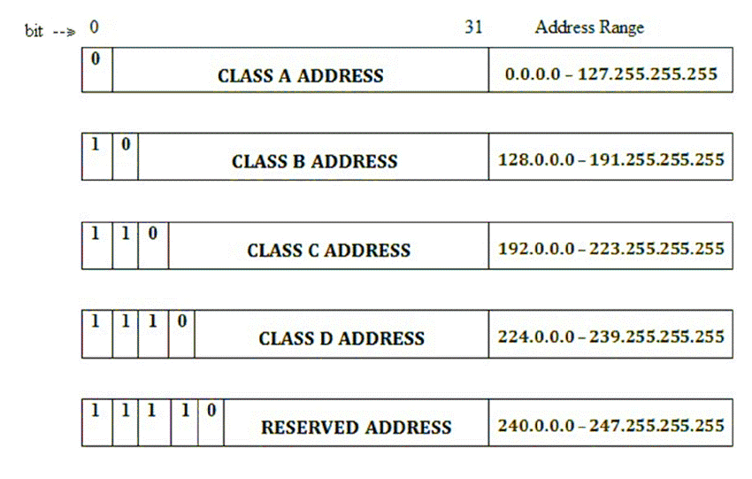**Classes of an IPv4 Addresses: -** There are around 4.3 billion IPv4 addresses and managing all those addresses without any scheme is next to impossible. Let’s understand it with a simple example. If you have to find a word from a language dictionary, how long will you take? Usually, you will take less than 5 minutes to find that word. You are able to do this because words in the dictionary are organized in alphabetical order. If you have to find out the same word from a dictionary that doesn’t use any sequence or order to organize the words, it will take an eternity to find the word. If a dictionary with one billion words without order can be so disastrous, then you can imagine the pain behind finding an address from 4.3 billion addresses.

1. **IPv6: -** Internet Protocol Version 6 (or IPv6) is a successor of IPv4 Address standard developed by IETF, which is designed to solve IPv4 address exhaustion problem. IPv4 uses a 32-bit numbering scheme to represent an IP address, which has an address space of 232 or 4.3 billion. IPv6, on the other hand, uses a 128-bit numbering scheme (2128) which has big enough address space for many decades to come. IPv6 is intended to replace the IPv4, but the introduction of the CIDR (Classless Inter-Domain Routing) allocation scheme in 1993 within the IPv4 prolonged lifespan of IPv4 Addresses**.**

**IPv6 can be written as :** fe80::6e06:fb44:273d:c800%6

But, there is a problem with the IPv4 address. With IPv4, we can connect only the above number of 4 billion devices uniquely, and apparently, there are much more devices in the world to be connected to the internet. So, gradually we are making our way to IPv6 Address which is a 128-bit IP address. In human-friendly form, IPv6 is written as a group of 8 hexadecimal numbers separated with colons (:)

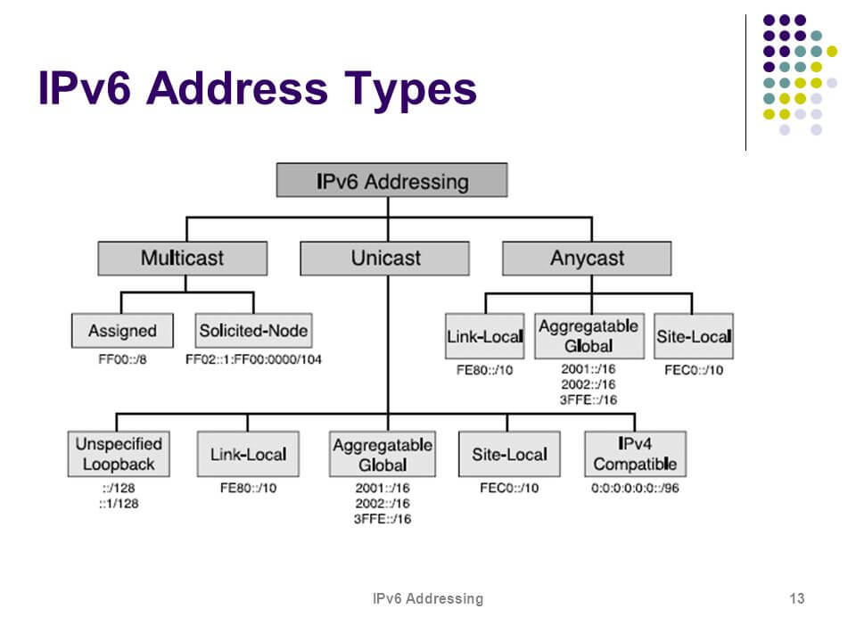**Classes of IPv6 addresses:-**

**Classification of an IP Address: -**

An IP address is classified into the following types:

1. **Public IP Address: -** This address is available publicly and it is assigned by your network provider to your router, which further divides it to your devices.
2. **Private IP Address: -** This is an internal address of your device which are not routed to the internet and no exchange of data can take place between a private address and the internet.
3. **Dynamic IP Address:** When you connect a smartphone or computer to the internet, your Internet Service Provider provides you an IP Address from the range of available IP Addresses. Now, your device has an IP Address and you can simply connect your device to the Internet and send and receive data to and from your device.
4. **Static IP Address: -** Static address never changes. They serve as a permanent internet address. These are used by DNS servers. What are DNS servers? Actually, these are computers that help you to open a website on your computer. Static IP Address provides information such as device is located in which continent, which country, which city, and which Internet Service Provider provides internet connection to that particular device.
5. **Shared IP addresses: -** Many websites use shared IP addresses where the traffic is not huge and very much controllable, they decide to rent it to other
6. **Dedicated IP addresses: -** A dedicated IP Address is an address used by a single company or an individual which gives them certain benefits using a private Secure Sockets Layer (SSL) certificate which is not in the case of a shared IP address. It allows to access the website or log in via File Transfer Protocol (FTP) by IP address instead of its domain name.
7. **Lookup IP addresses: -** To know your public IP, you can simply search “What is my IP?” on google. Other websites will show you equivalent information: they will see your public IP address because, by visiting the location, your router has made an invitation/request and thus revealed the information.

* **On Windows :-** Click Start and type “cmd” in the search box and run the command prompt. In the black command prompt dialog box type “ipconfig” and press enter. You will be able to see your IP Address there.
* **On Mac :-** Go to system preferences and select Network, you will be able to see the information regarding your network which includes your IP Address.

**Protect and hide IP address: -**

To secure and hide your IP address from unwanted people always remember the following points:

• Use a proxy server.

• Use a virtual private network (VPN) when using public Wi-Fi, you are traveling, working remotely, or just want some privacy.

• Change privacy settings on instant messaging applications.

• Create unique passwords.

• Beware of phishing emails and malicious content.

• Use a good and paid antivirus application and keep it up to date.

• It is also not recommended to use torrent or pirated websites which are a threat to your online identity and can compromise your device or mails or any other information about you.